**Output screenshots:  
  
1) Wordpress websites on EC2 instances suing CloudFormation.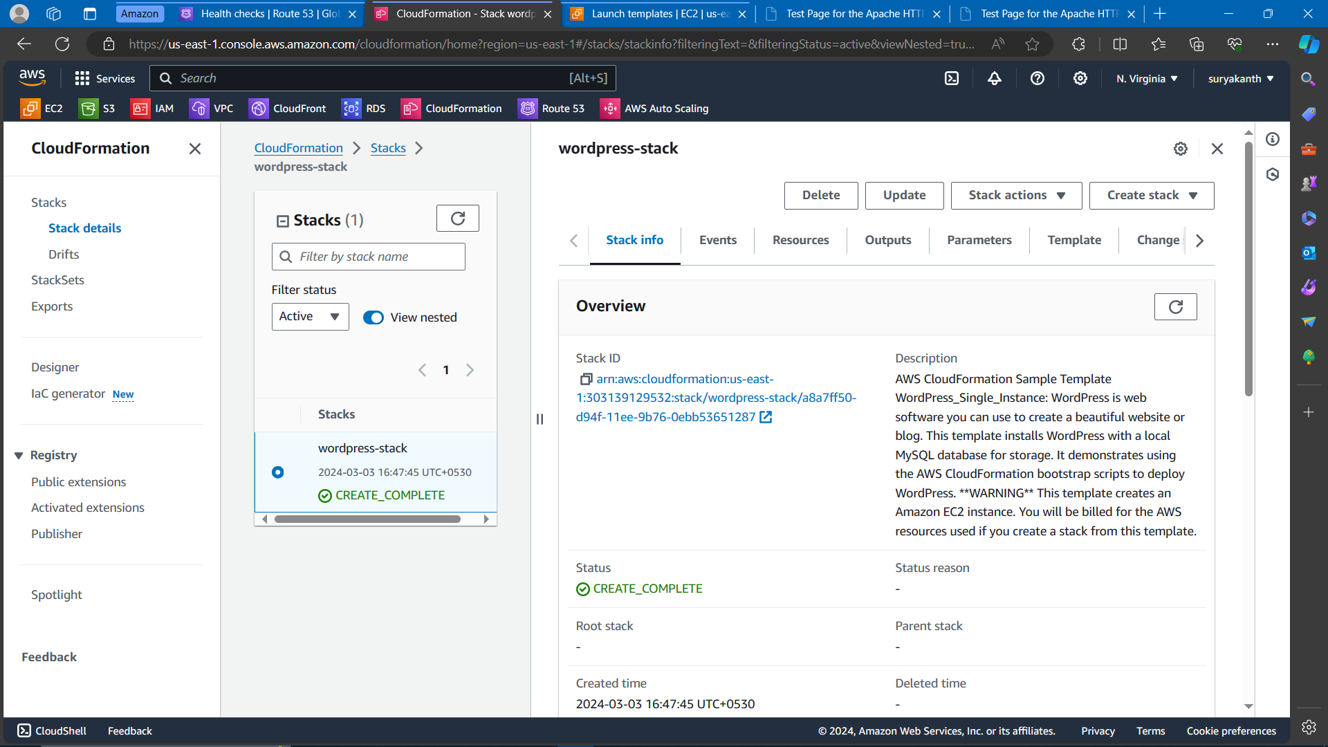 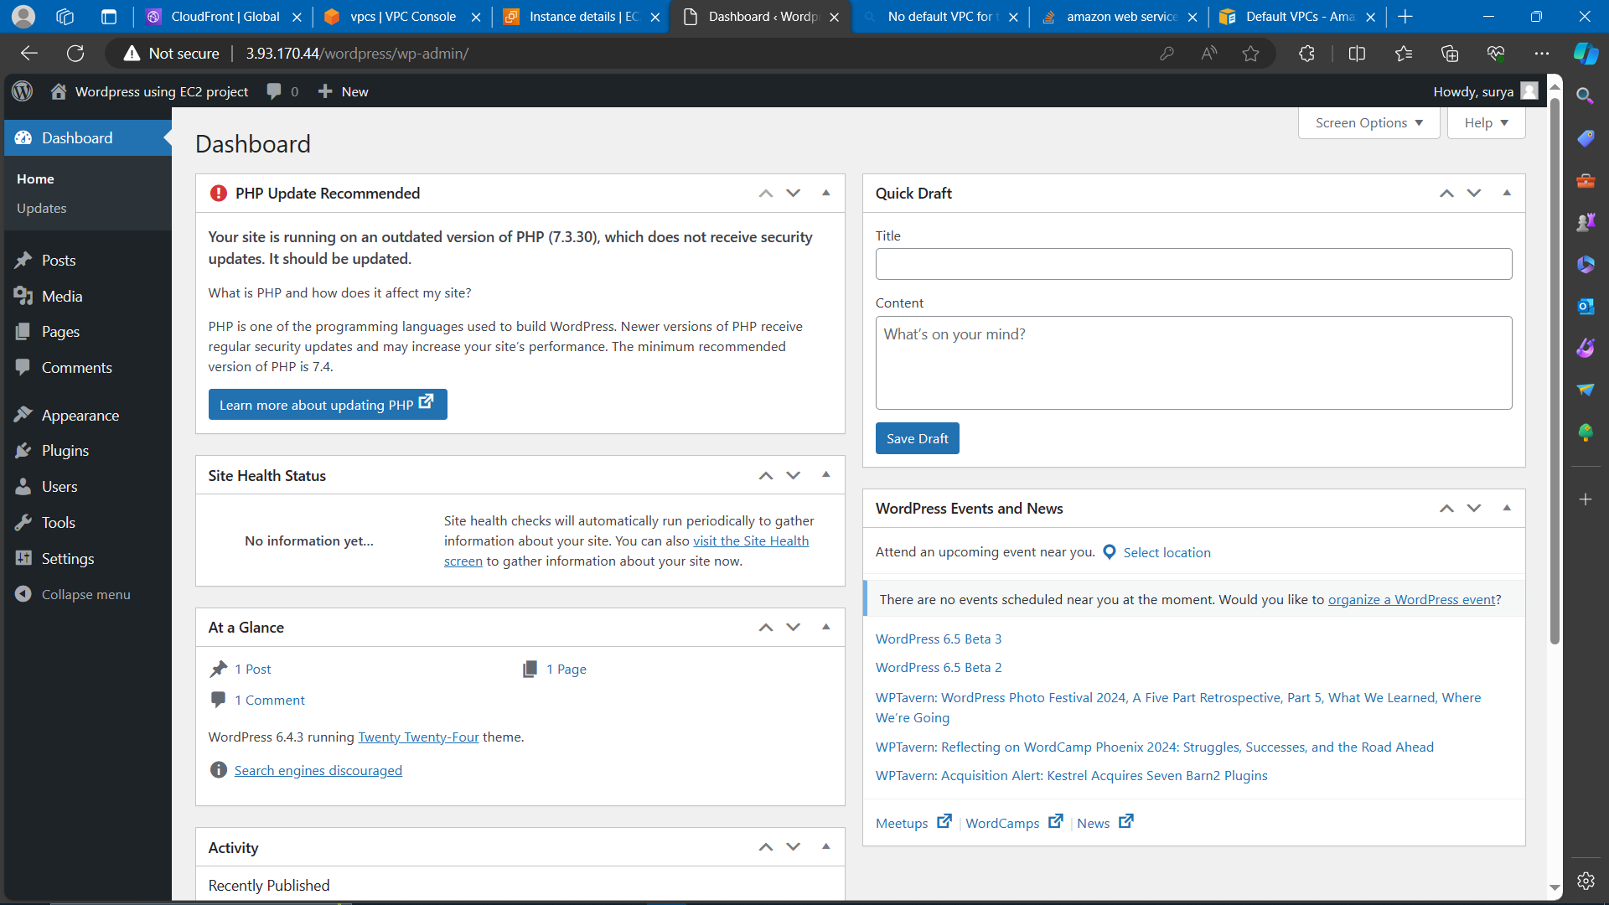  
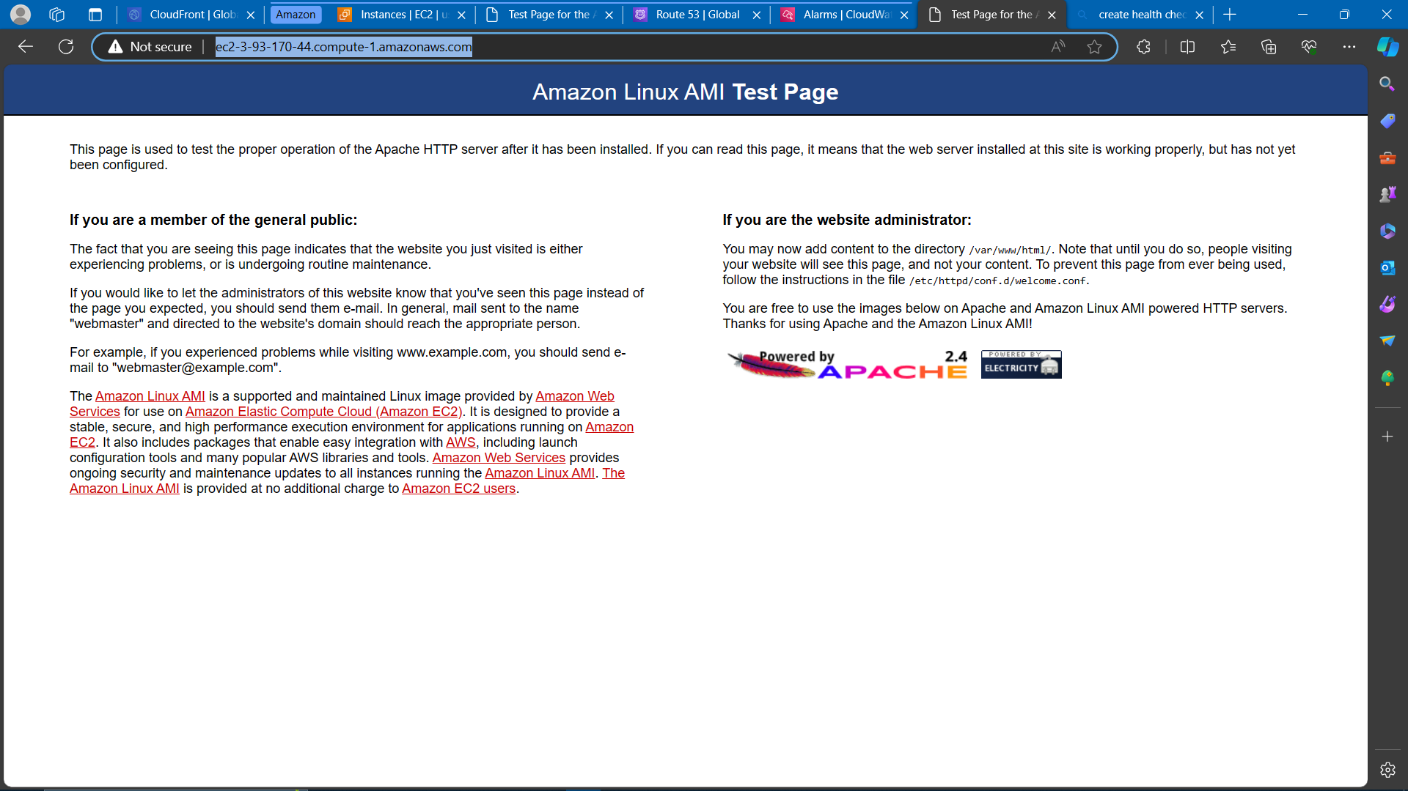  
  
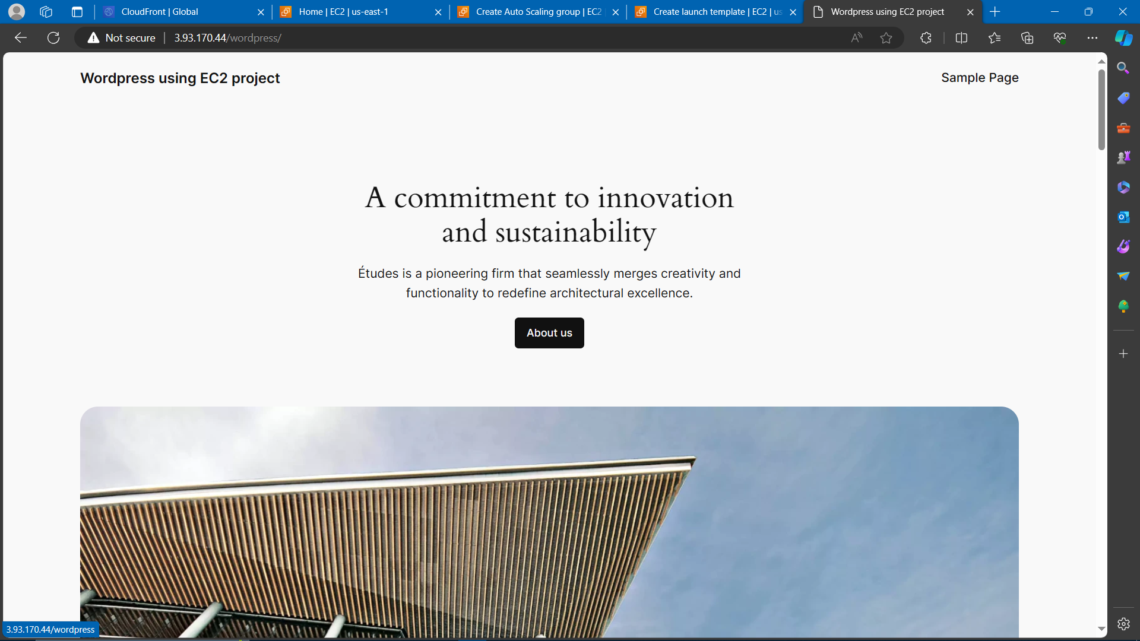  
  
2) Wordpress EC2 instance configuration:**

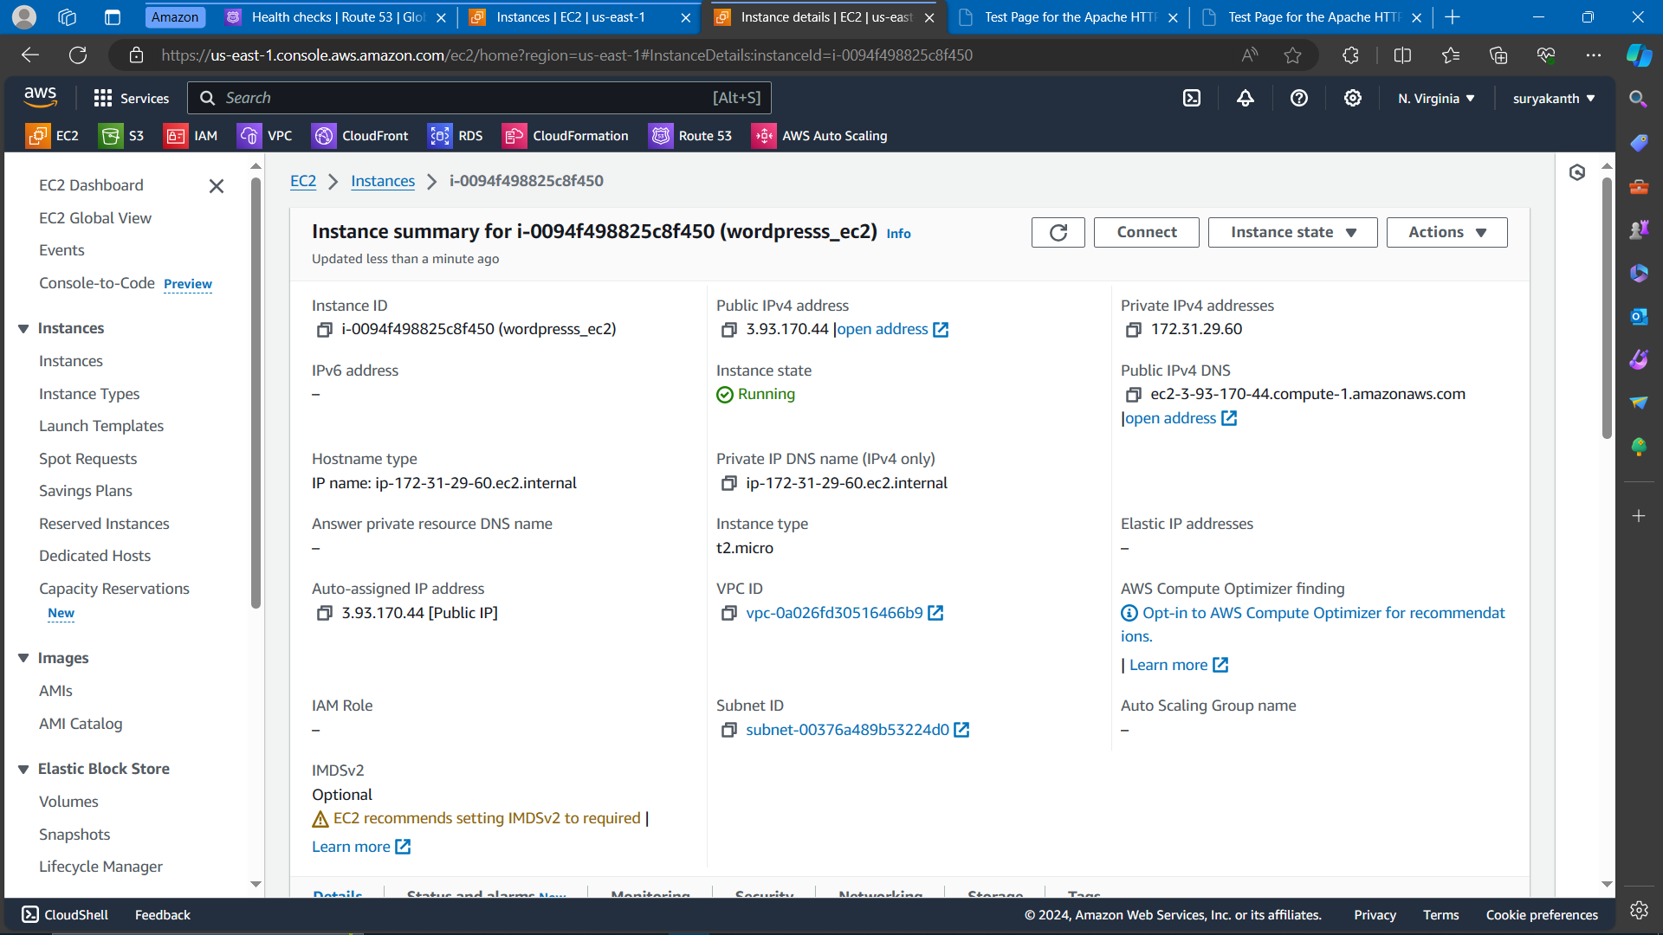

**3) Launch template for Autoscaling configuration:  
  
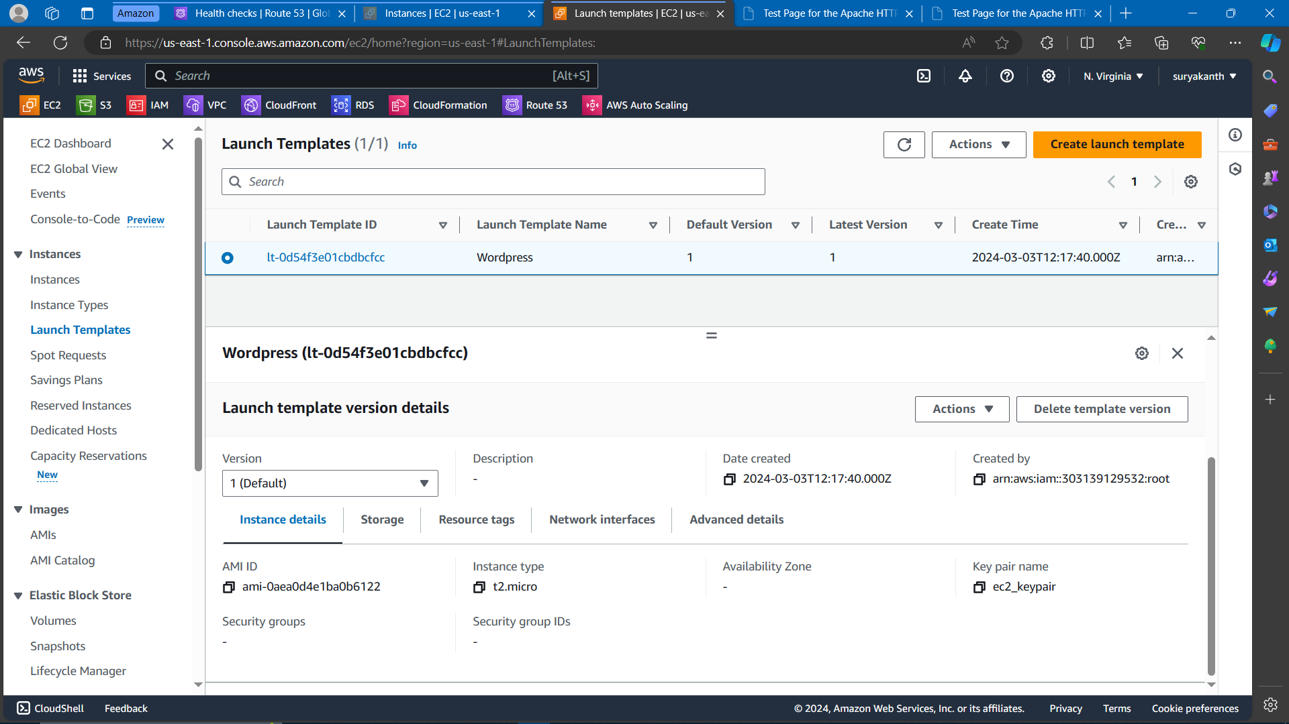  
  
4) Autoscaling configuration:  
  
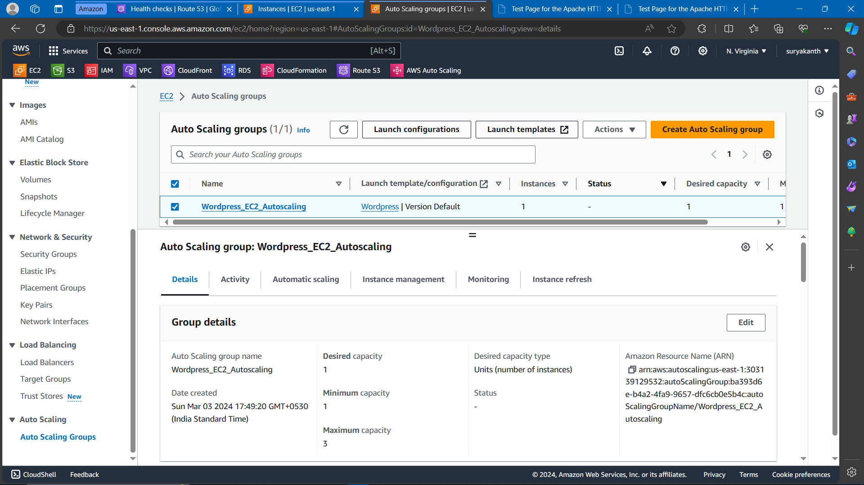  
  
  
  
5) Health check using Route 53 monitoring:  
  
